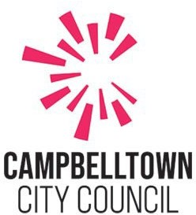

**Planning Proposal**

**80 O’Sullivan Road (543 Pembroke Road), Leumeah November 2023**

**Executive Summary**

* Council has received an owner-initiated Planning Proposal Request (PPR) seeking an amendment to Campbelltown Local Environmental Plan 2015 (CLEP 2015) for 80 O’Sullivan Road, Leumeah (also known as 543 Pembroke Road) to increase the maximum permissible height of building under the CLEP 2015 from 12 m to 38.5 m and 33 m and establish a floor space ratio of 2:1 for the site.
* The subject land is an irregular lot that has a site area of 8117 m² and is located on the southern side of Leumeah Railway Station. The property is zoned MU1 Mixed use. The site is currently occupied by 2 commercial uses being the Club Hotel and Liquor Stax.
* The PPR is accompanied by an urban design report providing a conceptual site layout and a building design for the site. The report also includes a concept masterplan for the wider area which shows building envelopes and pedestrian linkages through the site.
* The PPR has been assessed in accordance with the state and local strategic planning framework, including the Reimagining Campbelltown City Centre Master Plan.

# Introduction

This Planning Proposal explains the intent of, and justification for, the proposed amendment to the Campbelltown Local Environmental Plan 2015 (CLEP 2015) Maximum Height of Buildings and Floor Space Ratio maps for property known as No.543 Pembroke Road, Leumeah (Lot 201 DP 1052199).

The proposed amendment seeks to amend the maximum height of building map to provide a height limit of 33m to part of the site and a height limit of 38.5 m to the rest of the site and to also amend the floor space ratio map to indicate a maximum floor space ratio of 2:1 for the site.

# The Site

The subject site is located on the eastern side of O’Sullivan Road and forms part of the business area located on the southern side of Leumeah Railway Station which contains a variety of commercial uses.

The site has an area of 8,117 m² with a 40 m frontage to O’Sullivan Road. The site also has vehicular access to Pembroke Road via a right of way over the adjoining lot which is currently vacant. The site is adjoined by 4 lots to the northern boundary including a Council owned parcel of land (Lot 100 DP 14782). The State Government owns 2 adjoining lots; one of which adjoins the eastern boundary and the other lot adjoins the southern boundary from which vehicular access is currently obtained (refer to Figure 1 below).

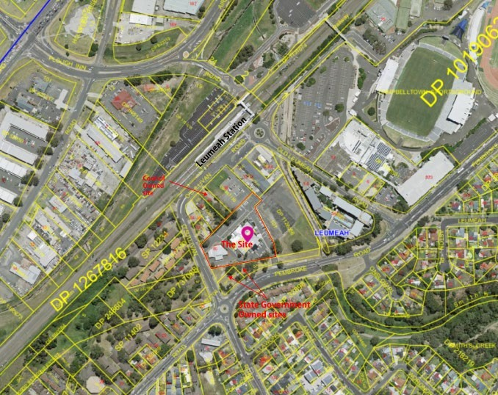

Figure 1: Aerial Photo of the Subject Site

The site consists of a single lot that has 2 existing commercial licenced premises which are the Club Hotel and Liquor Stax. The site has sporadic vegetation, with mature gum trees.

Smiths Creek is within close proximity to the site, part of which is a concrete lined channel that immediately adjoins the vacant parcel located to the east of the subject site.

The subject site is located in close proximity to Leumeah Railway Station and Campbelltown Stadium. The site is also in a neighbourhood with a range of land uses including, the Tennis Club, the West League Club, a mixed use residential apartment building, neighbourhood shops including an IGA store, post office, butcher, pharmacy, liquor shop, news agent, medical practice, dentist, the club hotel, coffee shop and a discount shop and car parking.

A majority of the buildings in the surrounding area are low rise comprising 1 - 2 story buildings with the exception of the mixed-use residential building, which consists of 7 - 8 storeys shown in the photo below.

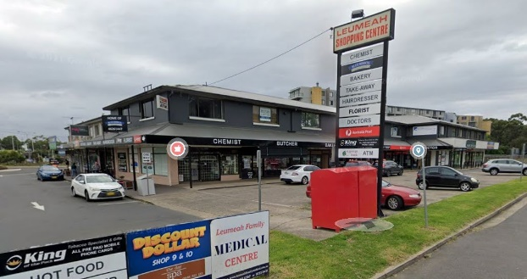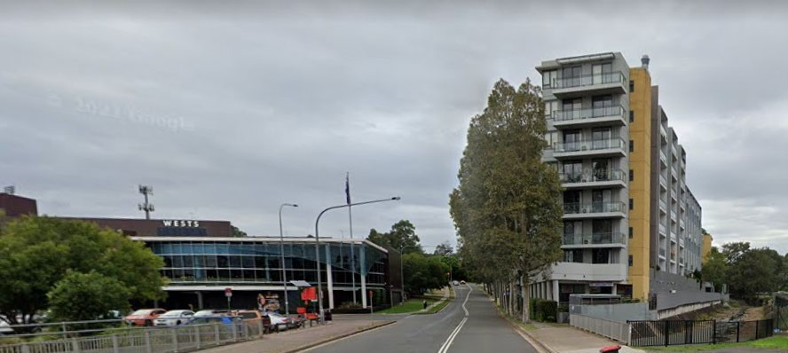

Figure 2: Leumeah Centre - Photos showing the Wests Leagues Club, the mixed-use apartment building and the shopping centre.

# Background

* The subject site was zoned 10(c) - Local Comprehensive Centre Zone under the Campbelltown (Urban Area) Local Environmental Plan 2002. The site is currently zoned MU1 Mixed use under the Campbelltown Local Environmental Plan 2015 (CLEP 2015).
* A meeting was held between the applicant and Council prior to the lodgement of the PPR on 27 May 2021.
* The Councillors were briefed on the PPR on 20 July 2021 and on 17 May 2022.
* The PPR was lodged with Council on 26 July 2021.

# Existing Zoning, development standards and local provisions under the CLEP 2015 Zoning: MU1 Mixed Use

**Building Height**: 12 m

**Floor Space Ratio:** The site is not subject to a Floor Space Ratio (FSR) development standard.

**Additional land Uses:** A Pub is permitted with development consent in the MU1 zone (a pub is a type of food and drink premises which is a type of retail premises which is a type of commercial premises.) The use of the site as a Pub is also listed in schedule 1 of the CLEP 2015 and therefore the use of the site as a Pub is also permissible with consent due to the operation of Clause 2.5 of the CLEP 2015.

Properties to the north of the site have the same zoning as the subject site. The adjoining property to the south is zoned SP2 Classified Road and property on the opposite side of O’Sullivan Road is zoned R3 medium density residential.

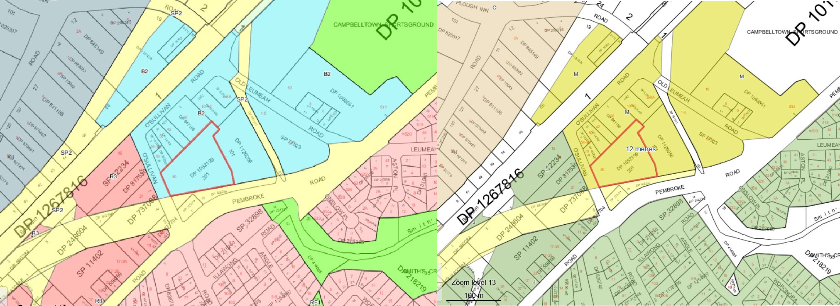

Figure 3: Extract of zoning and Maximum Height of Buildings Maps from CLEP 2015

The Planning Proposal has been prepared in accordance with the *Environmental Planning and Assessment Act 1979* (EP&A Act) and the Department of Planning and Environment’s ‘Local Environmental Plan Making Guideline’ August 2021.

# Part 1 – Objectives or Intended Outcomes

To increase dwelling and population densities within a walking distance from the Leumeah railway station and provide for a housing choice in Leumeah. The proposal will also facilitate additional retail space within the centre.

# Part 2 – Explanation of provisions

The objective or intended outcomes of the Planning Proposal are as follows:

* + To amend the Height of Building Maps to increase the building height partially to 33 m and partially to 38.5 m (Figure 4).

To amend the Floor Space Ratio Map to provide an FSR of 2:1. The objectives and intended outcomes of the planning proposal will be achieved by amending the Height of Building Map and Floor Space ratio Map (Figure 3).

A draft Height of Building and a draft Floor Space ratio map is identified below.

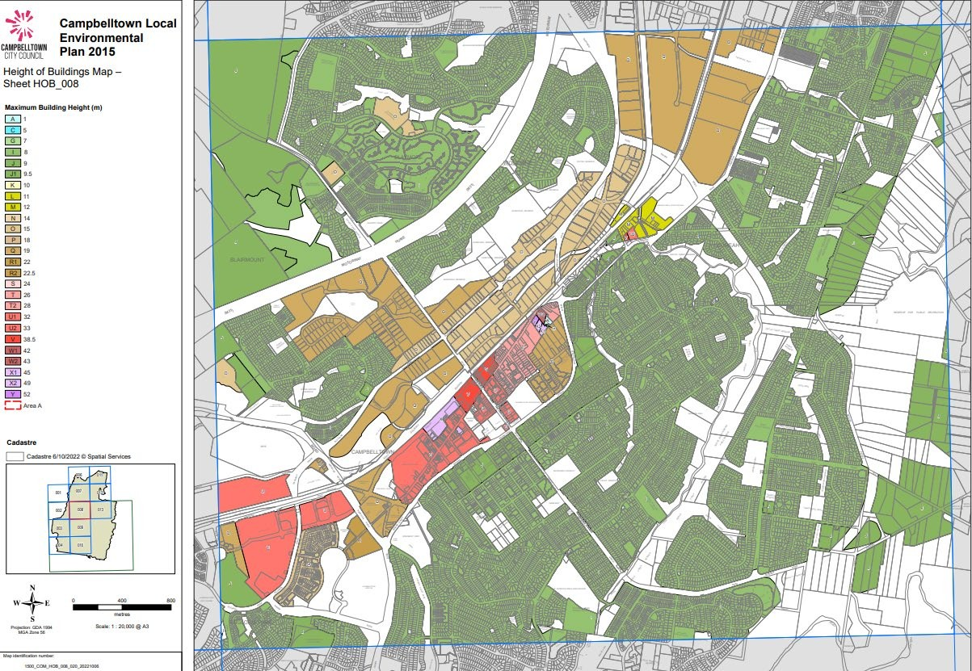

Figure 4: Proposed Height of buildings map

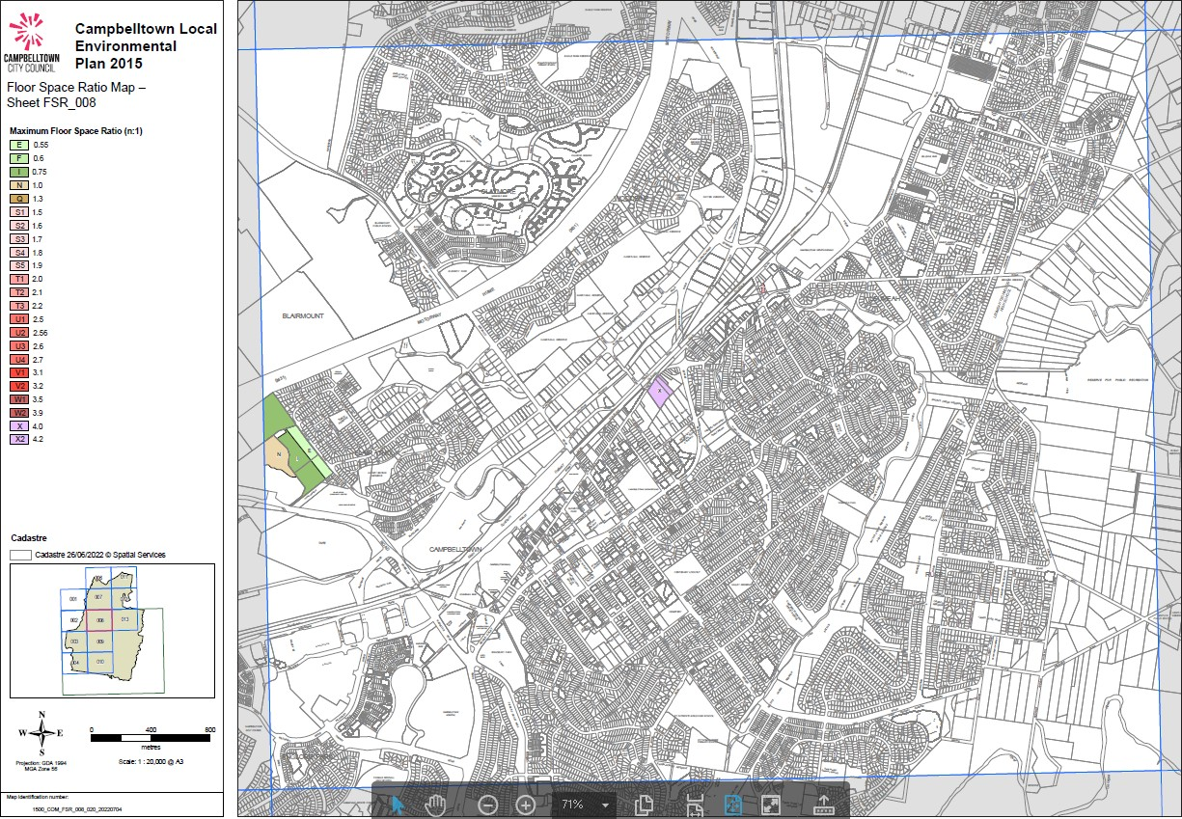

Figure 5: Floor space ratio map

# Part 3 – Justification

**Section A – Need for the planning proposal.**

1. **Is the planning proposal a result of any strategic study or report?**

The Planning Proposal is not a direct result of any strategic study or report, however, is consistent with key strategies including the Greater Sydney Region Plan, Western City District Plan and the Glenfield to Macarthur Urban Renewal Corridor Strategy.

# Is the planning proposal the best means of achieving the objective or intended outcomes, or is there a better way?

Yes.

The Planning Proposal is the best way to achieve the intended outcomes and objectives. Proceeding with a stand-alone planning proposal is considered appropriate in this instance and will assist in the delivery of the Leumeah Precinct Plan in the Glenfield to Macarthur Urban Renewal Corridor Strategy.

# Section B – Relationship to strategic planning framework

1. **Is the planning proposal consistent with the objectives and actions of the applicable regional, sub-regional or district plan or strategy (including any exhibited draft plans or strategies)?**

Yes.

The Planning Proposal is consistent with the relevant objectives and actions outlined in the Greater Sydney Region Plan and the Western City District Plan.

# Greater Sydney Region Plan

The Plan provides a framework for the predicted growth in Greater Sydney. The Plan identifies key goals of delivering a metropolis of three 30-minute cities through four key themes, infrastructure and collaboration, liveability, productivity and sustainability.

The Planning Proposal is considered to be consistent with the Greater Sydney Region Plan as it aims to provide a local centre with a mixed-use centre comprising of retail and residential with a sports and entertainment precinct in the greater locality.

# Western City District Plan

The Western City District Plan sets out priorities and actions for the Western Parkland City which are structured on themes that are based on the Greater Sydney Region Plan.

Leumeah is part of the Campbelltown-Macarthur metropolitan cluster identified within the Western City District Plan. Its location has been identified as providing the metropolitan functions within the Macarthur region including concentration of jobs, a wide range of goods and services, entertainment, leisure and recreational activities. Campbelltown-Macarthur has been identified as a Collaboration Area which is led by the Greater Sydney Commission to support growth and change, deliver improved outcomes and address complex issues that require cross stakeholder solutions. The Campbelltown-Macarthur Place Strategy is a key outcome of the Collaboration Area and has been prepared in alignment with the Reimagining Campbelltown City Centre Master Plan. As such the PP is considered to align with the Campbelltown Macarthur Place Strategy.

# Glenfield to Macarthur Urban Renewal Corridor Strategy

The Glenfield to Macarthur Urban Renewal Corridor Strategy (Corridor Strategy) establishes a high level strategic planning framework to guide future housing, employment opportunities and infrastructure delivery along the Campbelltown rail corridor, forming part of the Greater Macarthur Priority Growth Area.

The subject site is within the area covered by the Leumeah Precinct Plan, being one of the seven train station precincts identified under the Corridor Strategy. The Leumeah Precinct Plan provides the vision for the future development of the city centre having regard to the long-term housing and employment needs for the area until 2036. As part of the desired future character and built form, the subject site is identified under the Precinct Plan for mixed use retail and residential as described below:

“This area could accommodate a mix of retail and residential uses that would complement the character of the local area. Buildings would have ground floor retail that would provide local services for residents and commuters, with apartments above ranging from 7+ storeys in height. Detailed planning would be required to identify appropriate height and built form outcomes.”

The PP is broadly consistent with this vision in that it proposes a mix of retail and residential uses and building heights above seven storeys. The required detailed planning work referred to in the Precinct Plan has been undertaken by Council through the Reimagining Campbelltown City Centre Master Plan (which includes the central parts of Leumeah including the subject site). An assessment of the PP against the Master Plan can be found in the Report to Council dated 9 August 2022.

The Leumeah Precinct Plan identifies the need for regional cycle routes and pedestrian connections within the precinct, and the PP responds to this identified need via making provision for a through site link to facilitate pedestrian access to Leumeah Station. The urban design report also identifies a green pedestrian link over the existing concrete lined drainage channel for Smiths Creek, which is consistent with the Leumeah Precinct Plan.

The Leumeah Precinct Plan identifies a proposed ‘green link’ connection between the corner of O’Sullivan Road and Pembroke Road headed in a diagonal direction, over the subject site, towards Leumeah Station. The proposed through site pedestrian link proposed within the urban design analysis is generally consistent with the connection path shown on the map. The through site link is required to be ‘followed through’ on adjoining properties to ensure connection to Leumeah Station, which do not form part of this PP. While the site through link is not proposed to be supported by a zoning amendment to the CLEP 2015 it is proposed that it be included in a site specific DCP.

# Is the planning proposal consistent with a council’s local strategy or other local strategic plan?

**Campbelltown Community Strategic Plan 2032**

Campbelltown Community Strategic Plan 2032 (CSP) is Council’s highest level strategic plan and outlines the strategic direction of Council for a 10-year period based on the feedback of the local community and research on successful and resilient communities.

The purpose of the CSP is to identify the community’s main priorities and aspirations for the future and to plan an approach to achieve these goals. The CSP has been structured to address key outcomes that Council and other stakeholders will work to achieve. These outcomes are:

* Outcome 1: Community and belonging.
* Outcome 2: Places for people
* Outcome 3: Enriched natural environment
* Outcome 4: Economic prosperity
* Outcome 5: Strong leadership

These outcomes will be achieved through the implementation of strategies identified within the CSP. The following strategies are considered the most relevant in the consideration of this

PP:

* 2.1.1 – Provide public places and facilities that are accessible, safe, shaded and attractive
* 2.2.1 – Ensure transport networks are integrated, safe and meet the needs of all people.
* 2.3.1 - Ensure all people in Campbelltown have access to safe, secure, and affordable housing
* 3.1.2 – Ensure urban development is considerate of the natural environment
* 4.1.1 – Provide high quality and diverse local job opportunities for all residents
* 4.2.1 – Support the growth, productivity and diversity of the local economy
* 5.1.1 – Increase opportunities for the community to engage and collaborate with Council and key delivery partners

The PP is considered to be broadly consistent with the above strategies.

# Campbelltown Local Strategic Planning Statement (LSPS)

The Campbelltown Local Strategic Planning Statement (LSPS) came into effect on 31 March, 2020. All planning proposals are now required to demonstrate consistency with the LSPS.

A number of actions within the LSPS are relevant to the proposal, and an assessment of the PPR against these actions is contained within the table below.

|  |  |
| --- | --- |
| **Action** | **Assessment of Proposal against action** |
| 1.11 Support the creation of walkable neighbourhoods to enhance community health and wellbeing and create liveable, sustainable urban areas | The redevelopment scenario proposes a through-site link with landscaped public open space as well as a private open space area on Level 1 for the future residents of the dwelling. |
| 1.17 Ensure open space is well connected via pedestrian and cycle links | As above |
| 10.10 Investigate opportunities to enhance commercial amenity and ongoing economic viability through improvements to walking, cycling and public transport accessibility to create stronger centres | The PP is proposing commercial space on the ground floor including the retention of Leumeah Hotel which will contribute to economic growth and employment opportunities. |
| 13.1 Plan and implement local infrastructure that enables our growing population to use alternative methods of transport, such as walking and cycling, to move quickly and easily around the city, to connect to public transport and assist in easing traffic congestion | The site is within close proximity to the train station which provides access to public transport as well as being located across the road from Smiths Creek Reserve. |

|  |  |
| --- | --- |
| 2.5 Contain urban development to existing urban areas and within identified growth and urban investigation areas, in order to protect the functions and values of scenic lands, environmentally sensitive lands and the Metropolitan Rural Area | The PP seeks to increase residential density within urban land and would therefore help meet the dwelling targets, thus relieving development pressure on scenic lands, environmentally sensitive lands and the Metropolitan Rural Area and help protect their functions. |
| 2.12 Promote housing diversity through local planning controls and initiatives | The proposal is generally consistent with this action, given that it proposes higher density housing. |
| * 1. Ensure that sufficient, quality and accessible open space is provided for new urban areas.   2. Ensure that quality embellishment for passive and active recreation is provided to new and existing open space to service new residential development and redevelopment of existing urban areas.   3. Ensure open space is provided where it will experience maximum usage by residents, with maximum frontage to public streets and minimal impediments.   6.25 Work towards residents being a maximum of 400 m from quality open space | There is a short supply of embellished public open space within Leumeah and there may be opportunity to upgrade and enhance the public open space and walkways within Smith Creek Open space, which is located within a walking distance from the site. |
| 7.11 Identify appropriate building heights through design requirements to ensure that solar access is not restricted in open space areas adjoining multi-storey developments | There are no open space areas adjoining the subject site that would be affected by overshadowing. |
| 9.8 Promote the development and intensification of Campbelltown’s existing agglomerations to boost productivity and competitive edge | The subject site is located within a business zone that provides economic and employment opportunities. The PP will maintain this by providing a mix of commercial and residential areas in an accessible area. |
| 10.5 Continue to recognise the dynamic and evolving nature of centres, their ability to | Should the PP be progressed, it would result in the intensification of the precinct including |

|  |  |
| --- | --- |
| become activated and integrated mixed-use hubs which are highly productive and liveable places, and the potential of large and existing retail providers to offer local employment.  10.15 Continue to recognise and plan for a range of retail uses within centres, and enable appropriate retail growth in centres that have the capacity and demand to accommodate additional retail growth | the provision of additional retail uses within close proximity to public transport. This would increase activity in this location and would result in a more efficient and productive use of this land by intensifying economic activity on the site and introducing a large number of new residents to Leumeah. |
| 10.22 Implement the Reimagining | An assessment of the PP against the |
| Campbelltown Phase 2 Master Plan and | Reimagining Campbelltown Phase 2 Master |
| associated initiatives | Plan is found below. The PP is considered to |
|  | be generally consistent with the Master Plan, |
|  | and the PP would assist in the achievement of |
|  | the strategic growth pillars and |
|  | commitments. |

# Reimagining Campbelltown City Centre Master Plan

The Reimagining Campbelltown project commenced in late 2017. Phase 1 outlined the vision for the future of the Campbelltown, Macarthur and Leumeah stating that the economy and built form of these centres will need significant re-structuring to ensure that projected population growth can be accommodated across the Western Parkland City by 2036. This vision formed the basis of the Reimagining Campbelltown City Centre Master Plan.

At its meeting on 14 April 2020, Campbelltown City Council resolved to endorse and exhibit Reimagining (Phase 2) - Campbelltown City Centre Master Plan 2020. The Plan was publicly exhibited until July 2020. Council considered submissions made during exhibition at its meeting on 13 October 2020 and adopted the masterplan in the form it was exhibited with only minor changes.

The vision for the plan is to elevate the Campbelltown City Centre (which includes the parts of Leumeah near the Leumeah Railway Station) to the status of a Metropolitan CBD, a leading centre of health services, medical research and tech-related activity that will be achieved through ambition, innovation and opportunity.

The vision for Reimagining Campbelltown City Centre is underpinned by a Place Framework. Comprising six strategic growth pillars and 25 commitments, it is the enduring decision-making framework to guide growth and investment for a more prosperous future. The 6 strategic growth pillars comprise the following:

1. Confident and Self Driven
2. Connected Place
3. Centre of Opportunity
4. No Grey to be Seen.
5. City and Bush
6. The Good Life

An assessment of the PP has been undertaken against the 6 strategic growth pillars and corresponding 25 commitments for growing the Campbelltown City Centre. Whilst the PPR is broadly consistent with a number of pillars and commitments, the assessment below focuses on those that are of particular relevance to the PP.

A key component of the Master Plan is the development of a central precinct in Leumeah. The Master Plan provides a vision for Leumeah to be an integrated sports and entertainment precinct and will accommodate a significant amount of housing and employment opportunities for the Campbelltown LGA. The Master Plan describes the area as a ‘city in a valley’ and in this regard the building design will need to respect and respond to the natural landscape and maintain views from surrounding hills. In order to do this, varying building heights will provide a varied skyline.

The Master Plan has identified the site being suitable for high density mixed used development given its close proximity to the train station and sports and entertainment precinct. The key elements in the Master Plan for Leumeah include the following:

* Urban Village: A mixed use cluster that will include residential and commercial space and as such will be the heart of activity and services for the local community.
* Mixed Housing for All: Leumeah will provide a range of housing choice and affordability catering for the needs of the community and future population growth.
* Great Connectivity: Leumeah features 2 major green connections that hold cultural significance to the Dharawal people, provide the community with immediate access to major natural assets and parklands.
* Green Heart: the Bow Bowing creek and its surrounds is the green heart which offers open space for passive and active recreation activity.
* Leumeah Live: Leumeah Live is a vibrant sports and entertainment precinct anchored by Campbelltown Stadium and co-located with other regional sporting facilities and venues. As a major event precinct, it will include uses such as short-term accommodation, hotels, food and beverage options as well as some commercial space.
* People Place: A focus on reducing car dependency.

While the PP is not proposing to alter the existing zone of MU1 zone, it is aiming to increase the residential yield of the site by increasing the current building height from 12 m to 33 m and

38.5 m.

The PP, in principle, aligns with the above key elements in the Master plan as it would provide a mixed use high-density development within the Leumeah Centre that provides a connection to Leumeah Train Station and the sports and entertainment precinct and is considered to reflect the elements of a ‘city in a valley’ theme. It provides open space with the through-site link and landscaped public open space areas.

# Is the planning proposal consistent with applicable State Environmental Planning Policies?

The following table provides a brief assessment of consistency against each State Environmental Planning Policy (SEPP) relevant to the Planning Proposal.

|  |  |
| --- | --- |
| **State Environmental Planning Policies** | **Comment** |
| SEPP 65 – Design Quality of Residential Apartment Development | The planning proposal is not inconsistent with the SEPP.  Residential apartment development is proposed as part of this Planning Proposal with a detailed assessment against the SEPP undertaken at the development application stage.  The site is zoned MU 1 where shop top housing is permissible with development consent. |
| SEPP (Biodiversity and Conservation) 2021 | The planning proposal is not inconsistent with  the SEPP. |
| SEPP (Building Sustainability Index: BASIX) 2004 | Future development of the site would take into consideration the requirements of the SEPP. |
| SEPP (Exempt and Complying Development Codes) 2008 | Not relevant to the Proposal |
| SEPP (Housing) 2021 | The proposal is consistent with the SEPP. Any future development on the site may incorporate housing types identified in the  SEPP which would be considered in conjunction with the SEPP. |
| SEPP (Industry and Employment) 2021 | Any future development for signage for the retail component of the proposal would be  considered in future development applications. |
| SEPP (Planning Systems) 2021 | The planning proposal is not inconsistent with the SEPP. The proposal does not propose any  state significant infrastructure or development on Aboriginal land. |
| SEPP (Precincts – Eastern Harbour City) 2021 | Not relevant to the Proposal. |
| SEPP (Precincts – Western Parkland City) 2021 | The planning proposal is consistent with the SEPP. |
| SEPP (Precincts – Central River City) 2021 | Not relevant to the Proposal. |
| SEPP (Precincts – Regional SEPP) | Not relevant to the Proposal. |
| SEPP (Primary Production) 2021) | Not relevant to the Proposal. |
| SEPP (Resilience and Hazards) 2021 | There is no history of contamination of the subject site. Notwithstanding, future development of the site would address the requirements of the SEPP. |
| SEPP (Resources and Energy) 2021 | The planning proposal is not inconsistent with the SEPP. The proposal does not seek to undertake any extractive industries or mining. |

|  |  |
| --- | --- |
| SEPP (Transport and Infrastructure) 2021 | The Planning Proposal was referred to TfNSW due to proposed access via Pembroke Road. A number of issues were raised by TfNSW including that no access would be allowed via  Pembroke Road with all access to the site needing to be via O’Sullivan’s Road. |

# Is the planning proposal consistent with applicable Ministerial Directions (s9.1 directions)?

The following table provides a brief assessment of consistency against each section 9.1 direction.

|  |  |
| --- | --- |
| **Consideration of s9.1 Directions** | **Comment** |
| **Focus Area 1: Planning Systems** | |
| 1.1 Implementation of Regional Plans | The planning proposal is not inconsistent with this Direction. The planning proposal would provide flexibility in the height of future buildings on the site and would provide a mixed-use development comprising of a  retail/hotel component and residential apartments. |
| 1.2 Development of Aboriginal Land Council land | The planning proposal does not involve State or Regional development and is not on  Aboriginal Land Council land. |
| 1.3 Approval and Referral Requirements | The planning proposal was referred to TfNSW for comment given that it proposed access via Pembroke Road. Comments were received with most of the issues raised able to be dealt  with when a future development application is lodged with Council. |
| 1.4 Site Specific Provisions | The proposal requires a floor space ratio map and a height of buildings map for the subject site. |
| 1.5 Parramatta Road Corridor Urban  Transformation Strategy | Not relevant to the Proposal. |
| 1.6 Implementation of North West Priority Growth Area Land Use and Infrastructure Implementation Plan | Not relevant to the Proposal. |
| 1.7 Implementation of Greater Parramatta Priority Growth Area Interim Land Use Infrastructure Implementation Plan | Not relevant to the Proposal. |
| 1.8 Implementation of Wilton Priority Growth Area Interim Land Use Infrastructure  Implementation Plan | Not relevant to the Proposal. |
| 1.9 Implementation of Glenfield to Macarthur Urban Renewal Corridor | The proposal is consistent with this Direction as the subject site is proposed to be a mixed-use retail and residential zone with the proposed planning proposal consistent with |

|  |  |
| --- | --- |
|  | this proposed zone. It also proposes active street frontages along O’Sullivan Road which will be accommodated for within the planning proposal as well as future development applications. |
| 1.10 Implementation of Western Sydney Aerotropolis Plan | The proposal is not inconsistent with the Plan. |
| 1.11 Implementation of Bayside West Precincts  2036 Plan | Not relevant to the Proposal. |
| 1.12 Implementation of Planning Principles for the Cooks Cove Precinct | Not relevant to the Proposal |
| 1.13 Implementation of St Leonards and Crows Nest 2036 Plan | Not relevant to the Proposal. |
| 1.14 Implementation of Greater Macarthur 2040 | The planning proposal is consistent with the Plan as it provides mixed use retail and residential in close proximity to the train station and does not impact on any future redevelopment of Campbelltown Sport  Stadium as a sports and entertainment precinct. |
| 1.15 Implementation of the Pyrmont Peninsula Place Strategy | Not relevant to the Proposal. |
| 1.16 North West Rail Link Corridor Strategy | Not relevant to the Proposal. |
| 1.17 Implementation of the Bays West Place Strategy | Not relevant to the Proposal. |
| **Focus Area 2** |  |
| Design and Place | Not relevant to the Proposal. |
| **Focus Area 3: Biodiversity and Conservation** |  |
| 3.1 Conservation Zones | Not relevant to the Proposal. |
| 3.2 Heritage Conservation | Not relevant to the Proposal. |
| 3.3 Sydney Drinking Water Catchments | Not relevant to the Proposal. |
| 3.4 Application of C2 and C3 Zones and Environmental Overlays in Far North Coast LEPs 26 | Not relevant to the Proposal. |
| 3.5 Recreation Vehicle Areas | Not relevant to the Proposal. |
| **Focus Area 4: Resilience and Hazards** |  |
| 4.1 Flooding | This direction applies when a relevant planning authority prepares a planning proposal that creates, removes or alters a zone or a provision that affects flood prone land. While the PPR is not proposing to alter the existing zone of MU1 Mixed Use, it is aiming to increase the residential yield of the site by increasing the current building height from 12 m to 33 m and  38.5 m.  The subject site is partially flood affected. The flood area is located on the eastern boundary. |

|  |  |
| --- | --- |
|  | The PPR is not supported by sufficient information and justification in relation to the flood issue and additional information has been sought from the applicant.  Given that only a small portion of the site is flood affected, and subject to further analysis, it is envisaged that the inconsistency with this direction is of minor nature. |
| 4.2 Coastal Management | Not relevant to the Proposal. |
| 4.3 Planning for Bushfire Protection | Not relevant to the Proposal. |
| 4.4 Remediation of Contaminated Land | This has been addressed in the report. |
| 4.5 Acid Sulfate Soils | Not relevant to the Proposal. |
| 4.6 Mine Subsidence and Unstable Land | Not relevant to the Proposal. |
| **Focus Area 5: Transport and Infrastructure** |  |
| 5.1 Integrating Land Use and Transport | Consistent.  The subject site is within 400 m of Leumeah Train Station and other forms of services such as buses which can provide access to jobs and amenities. |
| 5.2 Reserving Land for Public Purposes | Not relevant to the Proposal. |
| 5.3 Development Near Regulated Airports and Defence Airfields | Not relevant to the Proposal. |
| 5.4 Shooting Ranges | Not relevant to the Proposal. |
| **Focus Area 6: Housing** |  |
| 6.1 Residential Zones | Consistent.  The subject site is not located within a residential zone, although shop-top housing is a form of housing which is permissible within the Local Centre zone. The proposal is consistent with this Direction as additional dwellings would be in close proximity to existing infrastructure and services and would  provide for existing and future housing needs of the local area. |
| 6.2 Caravan Parks and Manufactured Home  Estates | Not relevant to the Proposal. |
| **Focus Area 7: Industry and Employment** |  |
| 7.1 Business and Industrial Zones | The proposal is consistent with this Direction as the proposal will incorporate the existing hotel and provide additional commercial/retail floor space.  The proposed amendment would increase the potential uses for the site in accordance with the MU1 Mixed Use zoning. |

|  |  |
| --- | --- |
| 7.2 Reduction in non-hosted short-term rental accommodation period | Not relevant to the Proposal. |
| 7.3 Commercial and Retail Development along the Pacific Highway, North Coast | Not relevant to the Proposal. |
| **Focus Area 8: Resources and Energy** |  |
| 8.1 Mining, Petroleum and Extractive Industries | Not relevant to the Proposal. |
| **Focus Area 9: Primary Production** |  |
| 9.1 Rural Zones | Not relevant to the Proposal. |
| 9.2 Rural Lands | Not relevant to the Proposal. |
| 9.3 Oyster Aquaculture | Not relevant to the Proposal. |
| 9.4 Farmland of State and Regional Significance on the NSW Far Coast | Not relevant to the Proposal. |

# Section C – Environmental, social and economic impact

1. **Is there any likelihood that critical habitat or threatened species, populations or ecological communities or their habitat will be adversely affected as a result of the proposal?**

No.

There is no critical habitat or threatened species, populations or ecological communities or habitat located on the site.

# Are there any other likely environmental effects as a result of the planning proposal and how are they proposed to be managed?

No.

It is anticipated that there will be no environmental effect as a result of the planning proposal. The proposal does not seek to amend the zoning of the site. The planning proposal seeks to increase the maximum permissible height of buildings for the site and limit development by including a maximum floor space ratio.

# Has the planning proposal adequately addressed any social and economic effects?

Yes.

While the Planning Proposal has not been supported by a social or economic assessment, it is anticipated that the planning proposal will not result on any negative impacts on social and economic matters.

The proposal will have social benefits, as it will provide more housing within close proximity to the railway line. It will also increase population within Leumeah Centre which will help the businesses within the Centre.

The proposal will also kick start the revitalisation of Leumeah Centre by facilitating the redevelopment of the site and potentially facilitate the provision of high standard public open spaces to all residents and the general public.

# Section D – State and Commonwealth Interests

1. **Is there adequate public infrastructure for the planning proposal?**

No.

The planning proposal may result in a need for additional public infrastructure and may impose additional demands on local infrastructure, public or community services. The site is located in close proximity to existing bus and train services.

This matter will be further confirmed, once the revised traffic study is prepared as there may be a need to upgrade some of the roads within the locality, in particular the roundabout at Pembroke and O’Sullivan Road.

There may be some additional matters in relation to infrastructure upgrades that may be raised as a result of the public exhibition and consultation with public authorities.

In addition, there is also a need for additional passive open space as Leumeah Centre. Potentially Smith’s Creek open space area, which is adjacent to the site can be upgraded to provide for the need of the future residents.

# What are the views of the State and Commonwealth public authorities consulted in accordance with the Gateway Determination?

Consultation will occur with any public authorities identified in the Gateway Determination.

# Part 4 – Mapping

The Planning Proposal seeks to amend the Floor Space Ratio map and the Maximum Height of Buildings map in CLEP 2015 as proposed below.

|  |  |  |
| --- | --- | --- |
| **Map** | **No** | **Requested Amendment** |
| Height of Buildings | HOB_008  Date 18 February 2022 | Amend by providing a height limit of 33m and 38.5 m. |
| Floor Space Ratio | FSR_008  Date 30 June 2021 | Amend by providing a floor space ratio of 2:1 |

# Current Map Height of Building Map

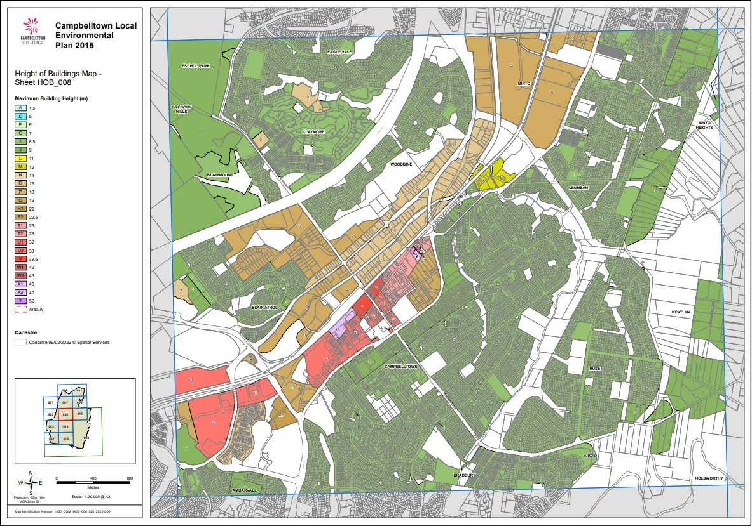

**Proposed Height of Building Map**



**Current Floor Space Ratio Map**

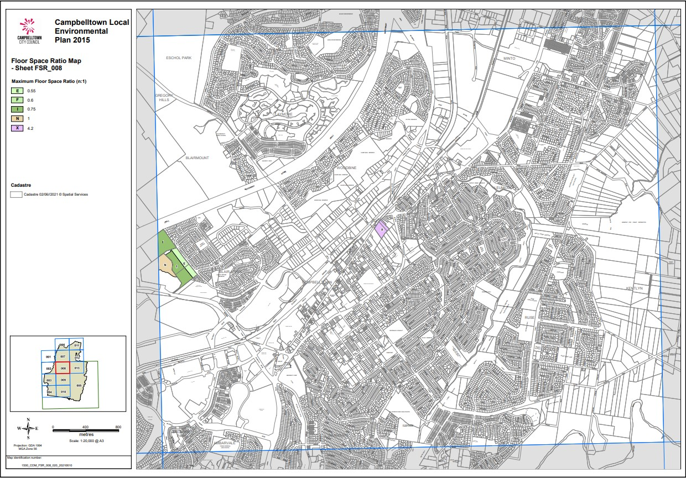

**Proposed Floor Space Ratio Map**



The current and proposed maps are attached to this proposal.

# Part 5 – Community consultation

The LEP Making Guideline 2021 provides four categories for planning proposals.

This planning proposal is considered to be a standard planning proposal as it aligns with the standard criteria under the LEP Making Guideline as shown in the table below:

|  |  |
| --- | --- |
| **Criteria** | **Comments** |
| To change the land use zone where the proposal is consistent with the objectives identified in the LEP for that proposed zone | The PP does not include an amendment to the current MU1 Mixed Use zone under the CLEP 2015 |
| That relates to altering the principal  development standards of the LEP | The PP includes an amendment to building  height and introduces an FSR of 2:1 |
| That relates to the addition of a permissible land use or uses and/or any conditional arrangements under Schedule 1 Additional Permitted Uses of the LEP | N/A |
| That is consistent with an endorsed District/Regional Strategic Plan and/or LSPS | The planning proposal is considered consistent with the LSPS and the regional and district plans – refer to the relevant section under this PP for more information |
| Relating to classification or reclassification  of public land through the LEP | NA |

In accordance with ‘the local environmental plan making guideline” prepared by the Department of Planning and Environment (2021), the proposal is considered to be a standard local environmental plan and accordingly the proposal will be publicly exhibited for 20 working days including the following:

An advertisement placed in any local paper in publication at the time of exhibition (potentially including the Macarthur Chronicle and Campbelltown – Macarthur Advertiser) identifying the purpose of the Planning Proposal and where the Planning Proposal can be viewed.

The Planning Proposal is to be exhibited on Council’s website [(www.campbelltown.nsw.gov.au](http://www.campbelltown.nsw.gov.au/)). Council’s libraries also have access to the website.

The planning proposal will also be made available on the NSW Planning Portal website [(www.planningportal.nsw.gov.au](http://www.planningportal.nsw.gov.au/)).

Letters will be sent to adjoining owners and all other owners within 100 m of the subject land.

# Part 6 – Key Issues

* 1. **Building Height**

The main purpose of the proponents PP is to increase the building height of the site from 12 m to part 33 m and part 38.5 m.

The Campbelltown Local Planning Panel considered an earlier version of the PPR and advised that:

* The proposed heights of 55 m and 43 m are significantly higher than that which would ordinarily be anticipated for an urban village.
* The height of the proposal having regard to the hierarchy of centres detailed in the Reimagining Campbelltown City Centre Master Plan which places Leumeah’s status as subservient to the main centre of Campbelltown.
* The need to transition the scale down towards the existing residential development on the opposite side of adjacent roads.

The current maximum 12 m building height (3-4 storey) for the site is considered too low and not in keeping with the Leumeah Precinct Plan in the Glenfield to Macarthur Urban Renewal Corridor Strategy. Currently, the tallest building in Leumeah Centre is an 8-story mixed use development. This existing building has maintained the human scale and issues of traffic and overshadowing have readily been addressed.

To determine an appropriate and suitable building height for this site, the following in-house detailed assessment has been undertaken:

1. Assessment against Reimagining Campbelltown City Master Plan, including the centre’s hierarchy.
2. Analysis of the RLs within the Campbelltown CBD from key points and sites.
3. Overshadowing on adjoining low density residential properties

# Assessment against Reimagining Campbelltown City Centre Master Plan including centres’ hierarchies.

The Reimagining Campbelltown City Centre Master Plan 2020 in relation to Leumeah Centre states:

…the urban village will be the heart of activity and services for the local community. As a mixed-use cluster, the village will include retail convenience, day and night dining options, as well as health and wellbeing services.

The reference to Urban Village within the Reimagining Campbelltown City Centre Master Plan provides a strong indication of the sense of place that is desired to be created at Leumeah. While the term Urban Village is not defined within the masterplan documentation nor within the legislative context of the NSW planning system, it is widely known that an urban village aims to create a sustainable community (similar to a village) while also has the required density of urban areas. Urban villages maintain human scale and have significant emphasis on activation at ground levels. There is no clear set of rules on the maximum building heights that should occur within an Urban Village.

The Reimagining Campbelltown City Centre Master Plan does not stipulate the desired maximum building heights within Leumeah Centre. It provides a context that includes hierarchy of building heights that shows where the greatest building height within Campbelltown and Leumeah Centres should occur. Within this context, the masterplan clearly indicates that Campbelltown CBD should have the highest buildings to reflect its main CBD status.

The maximum building height that has been endorsed by Council and is in effect within the Campbelltown CBD is for the former Factory Direct Outlet site (the DFO site) at 22-32 Queen Street and is at 52 m. Ideally, and according to the building height Map under the Reimagining Campbelltown City Centre Master Plan, the DFO site should have had a building height that is lower than sites within Leumeah Centre. Importantly, the height for this site was endorsed by Council, prior to the adoption of Reimagining Campbelltown City Centre Master Plan, and the Plan clearly provides the following important note:

NOTE: all planning proposals that had progressed to Gateway Determination prior to the start of Reimagining Campbelltown City Centre were assessed on merit at the time and cannot be used to determine height relativities of future proposals, or as a justification for the heights of future buildings.

It is anticipated that greater building heights will be endorsed closer to the Campbelltown Station and at the heart of the Campbelltown CBD.

As an outcome of the above assessment, the 55 m proposed by the PPR was reduced to 38.5 m and the 43 m proposed by the PPR was reduced to 33 m to better align with the urban village theme and the centres’ hierarchy within the Campbelltown LGA.

# Analysis of the RLs within the Campbelltown CBD from key points and sites.

Detailed analysis of the RLs within Campbelltown and Leumeah Centres has been undertaken to investigate the potential impacts of the requested building height on the skyline and the views.

The analysis considered the local view lines as outlined in the Reimagining Campbelltown City Centre Master Plan. Having regard to these important view lines, it is clear that any building on this site should have a maximum relative height of less than 100 m AHD (Australian Height Datum).

To better understand the visual impact of the proposed building height by the applicant within the context of the Campbelltown LGA a further comparison between some of the most prominent sites and buildings within Campbelltown LGA is presented in the table below:

|  |  |  |  |  |  |  |  |  |
| --- | --- | --- | --- | --- | --- | --- | --- | --- |
| **Location** | | | | | **Site RL at ground level** | **Top of Building RL**  **/** | **Building height in metres**  **/number** | **No of Storeys** |
| Campbelltown Hospital | | | | | 83.2 | 135.6 | 52.4 m | 12 |
| 22-32 Queen Street | | | | | 68 | 120* | 52* | 17* |
| 541 Pembroke Road, LEUMEAH NSW 2560 (Leumeah 7-8 storey mixed use retail/residential apartments) at the corner of Pembroke Road and Old Leumeah Road | | | | | 60 | 81.3 | 20.3 | 8 |
| Intersection of Campbelltown Road and Rose Payten Drive | | | | | 62 | - | - | - |
| Apartment building  Broughton streets | corner | of | Queen | and |  | 104.4 | 33.98 | 10 |
| Roundabout Badgally Road and Glenroy Drive | | | | | 98 | - |  |  |
| Centenary Park and Lookout | | | | | 126 | - | - | - |
| 95 Badgally Road, BLAIRMOUNT NSW 2559 | | | | | 126 | 132 |  |  |

|  |  |  |  |  |
| --- | --- | --- | --- | --- |
| Kanbyugal Reserve, Woodbine | 100 | - | - | - |
| Payten Reserve | 87 | - | - | - |
| Intersection of Campbelltown Road and Plough Inn Road | 56 |  |  |  |
| Applicant’s original PPR | 58 | **113** | 55 | 18 |
| Applicants revised PP | 58 | **96.5** | 38.5 | 12 |
| *Proposed and not built yet | | | | |

The above analysis indicates that an RL for the top of any building should be lower than 100RL so as to ensure centre hierarchy is maintained and the skylines as you enter Campbelltown are not highly impacted by the redevelopment of this site.

# Overshadowing on adjoining low density residential properties

Council staff have used 3D software to analyse and understand the impacts of the proposed building heights on surrounding properties. A reduced building height of 38.5 m and 33 m will ensure that all adjoining properties will have solar access that is above the minimum industry standard of 3 hours solar access on 21 June.

The above analysis (points 1-3) has informed the proposed revised building height of 38.5 m and 33 m for the site. It is considered this will:

1. Ensure that Leumeah Town Centre evolves into an ‘urban village’ centre to maintain human scale and centre’s hierarchy.
2. Have lesser impact on overshadowing on the low and medium density residential properties surrounding the site.
3. Still provide for higher densities within walking distance from the railway station
4. Maintain views and provide for acceptable visual impacts on the surrounding landscape and reserves.
5. Not significantly intrude in the skyline of Campbelltown as people entre the city from Campbelltown Road.

# Traffic and Access

A Traffic Assessment Report prepared by Traffix, Traffic and Transport Planners has been submitted in support of the proposal. The Traffic Assessment Report provides an assessment on car parking requirements, traffic and transport impacts and access and internal design requirements.

The report concluded the number of parking spaces proposed (albeit in a conceptual way) would be sufficient to cater for the proposal however a further assessment would be required for the lodgement of a development application for any future redevelopment on the site.

Traffic generation was modelled in SIDRA which identified that all intersections would operate with spare capacity with minor increases in the average delay. The vehicular access and internal design would all be designed in accordance with the relevant Australian Standards and would be assessed at the development application stage.

The PPR was referred to Council’s Traffic Engineers for an assessment of the proposal and the following comments were raised:

1. No access shall be allowed from Pembroke Road (state road) for the following reasons:
   * Flood water will enter the loading area and basement in 1 per cent AEP flood event which is not acceptable.
   * It’s highly likely that TfNSW will not support direct access to/from Pembroke Road.
2. The adopted low values of peak hour trip generation (for hotel, retail and apartment) may be attributed due to the closeness to the train station however the low values need to be supported by evidence. The traffic report is silent about the source of the data.
3. Insufficient detail has been provided about the nature of the hotel being proposed as it affects the trip generation and parking rates.
4. The low PM peak hour trip generation of 111 vehicles per hour is at odds with the provision of 320 off-street parking as the peak hour trip is closely related with the number of vehicles parked on site.
5. The submitted traffic report states that the intersection of O’Sullivan Road and Pembroke operates at LOS of A and B in peak hour AM and PM respectively, however, items numbers 3 and 4 above may impact the actual LOS. In addition, future scenario modelling of the 10-year design horizon has not been provided.

The PPR was referred to TfNSW for review and the following comments were provided that are required to be addressed prior to the approval of the PP:

* All site access be provided from the local road network i.e., from O'Sullivan Road. Given that a safe and practicable access to the site is available from O'Sullivan Road, TfNSW reiterates that it is not supportive of maintaining access from Pembroke Road. TfNSW requires that the proposal be amended to enable all site access from O'Sullivan Road prior to the finalisation of the plan. It should be noted that TfNSW will require existing vehicular access on Pembroke Road to be closed off and road reserve reinstated to the satisfaction of TfNSW at full cost to developer/s as part of the future development application/s.
* TfNSW advises that strategic investigations for the duplication of Pembroke Road corridor have been undertaken, however there is currently no funding allocated to develop the proposal further. The duplication is anticipated to affect existing vehicular access, and associated deceleration lane, to the site.
* It is unclear whether there is any Easement for Access (Right of Carriageway) at existing vehicular access on Pembroke Road which benefits adjoining land parcels. If so, the proposed site access on O'Sullivan Road should include such easements benefitting adjoining land parcel/s in consultation with affected landowners. This is to ensure that any adjoining land parcel/s, especially Lot: 101 DP: 1126056 with a frontage on Pembroke Road, which may be a current beneficiary to any such easement do not rely on access from Pembroke Road in the future.
* TfNSW advises that there is a plan to upgrade the roundabout of Pembroke Road, Rudd Road and O’Sullivan Road into a signalised intersection. However, this investigation is strategic in nature and there is currently no funding allocated to develop the proposal further.
* The northern approach of O’Sullivan Road at the Pembroke Road/Rudd Road roundabout currently has a pedestrian refuge. The indicative reference scheme appears to replace the refuge with a marked pedestrian (zebra) crossing. TfNSW advises that installing a marked pedestrian (zebra) crossing in close proximity to the roundabout could adversely affect its operation and could lead to potential road safety issues. Furthermore, the TIA report does not provide information on whether warrants for a marked pedestrian (zebra) crossing are met at this location. Given the above, TfNSW is not supportive of a marked pedestrian (zebra) crossing at this location.
* The indicative reference scheme appears to propose a marked pedestrian (zebra) crossing along proposed Green Pedestrian Link across Pembroke Road at the Smiths Creek bridge. It is noted that guardrails are currently provided on both sides of the bridge to maintain road safety. Given that there is a plan to upgrade the Pembroke Road/ Rudd Road/O’Sullivan Road roundabout to a signalised intersection in the future, TfNSW is not supportive of a marked pedestrian (zebra) crossing or a midblock signalised crossing on Pembroke Road at the location due to close proximity.
* The indicative reference scheme appears to show a driveway crossover on Pembroke Road immediately west of the Smiths Creek bridge. The driveway crossover appears to provide access to the adjoining land parcel (Lot: 101 DP: 1126056). It is highlighted that there is currently no driveway crossover at this location. TfNSW is unlikely to support a new access to Lot: 101 DP: 1126056 from Pembroke Road should it be a beneficiary of an Easement for Access (Right of Carriageway) on adjoining land parcel/s which would enable access from the local road network i.e., O'Sullivan Road.
* TfNSW considers that traffic surveys conducted in June 2021 are unlikely to be a true reflection of typical traffic conditions at the three modelled intersections, due to a general reduction in commuter trips during peak hours associated with temporary COVID-19 work- from-home arrangements. TfNSW advises that the Traffic Impact Assessment report should utilise available historical traffic survey data, say from 2018/19, to update intersection modelling. The historical traffic survey data may be available with Council or private traffic survey companies (at cost).
* TfNSW considers that the Existing Scenario (Base) modelling results do not reflect typical traffic conditions observed on site. The Existing Scenario (Base) model should be calibrated to reflect existing traffic conditions, including queue lengths, prior to progressing with modelling the Future Scenario (with development).
* While TfNSW has not reviewed SIDRA modelling files (.sip), based on the review of the Traffic Impact Assessment report, it appears that the 3 affected intersections may have been modelled as isolated intersections. Given the proximity of 3 modelled intersections, and considering observed traffic queue lengths on Pembroke Road, these intersections should be modelled as 'Networked' intersections rather than 'Isolated' intersections, if not already undertaken.
* While TfNSW has not reviewed SIDRA modelling files (.sip), if not already undertaken, the two signalised intersections should be modelled using key operational features (cycle time, phasing, etc.) that can be obtained from SCATS data sourced from TfNSW (at cost).
* The Traffic Impact Assessment report does not confirm the assessment year of the Existing and Future (with development) intersection performance results provided. Given that the traffic surveys have been undertaken in 2021, it is likely that the assessment year would be 2021. TfNSW however requests clarification in this regard.
* TfNSW highlights that it is not appropriate to undertake intersection assessment assuming 100 per cent development will be implemented in 2021 given that the development is still at the planning proposal stage. TfNSW advises that a reasonable delivery timeframe for the 100 per cent development should be adopted and modelled. A +10-year horizon assessment/modelling should then be conducted based on the 100 per cent development delivery timeframe to demonstrate that the development will not utilise spare capacity at the intersections and therefore will not bring forward future upgrades.
* The TIA report, including SIDRA intersection modelling files (.sip), should be updated to address above comments and submitted to TfNSW for further review and comment prior to the finalisation of the plan.
* The indicative reference scheme proposes provision of 320 car parking spaces for the proposal. Given the site’s good accessibility to public and active transport, TfNSW is supportive of measures to reduce private vehicle use including reduced maximum parking provision rates for the site within the LEP.
* At the time of submitting this PP, the (former) DPIE was currently undertaking an employment zone reform, which eventually combined the B1 Neighbourhood Centre and B2 Local Centre zones to create an MU1 Mixed Use zone, with a broader array of mandated permissible uses than currently occurs in the existing ‘B’ zones. This process has been completed and all references to the previous B1 and B2 zones have not been replaced with MU1 – Mixed Use. It was also recommended that the impact of this reform is considered in terms of potential uses and transport impacts.
* The proposal should include a transport infrastructure schedule and implementation plan identifying infrastructure improvements including land components, cost, timing and delivery responsibilities, funding mechanisms (to ensure equitable developer contributions towards infrastructure are obtained) and travel demand management and monitoring measures.

The applicant will need to provide additional information regarding traffic and access to address the above matters, prior to Council requesting a Gateway Determination. Delaying the update of the traffic study has ensured that the traffic study will be updated in relation to the endorsed building height determined by Council.

# Flooding

The subject site is partially flood affected. The flood area is located on the eastern boundary of the site. The planning proposal justification report has not addressed flooding. The depth of flood waters in the 1:100 event is at a maximum depth of approximately 500 mm. Council’s Engineers have reviewed the proposal and the following is a summary of their comments:

1. The subject site is a Flood Control Lot with respect to 1 per cent Annual Exceedance Probability (AEP) flood due to flooding from Smith’s Creek traversing the property.

A Flood Control Lot is defined in the State Environment Planning Policy (Exempt and Complying Development Codes) 2008 - REG 1.5 as “a lot to which flood related development controls apply in respect of development for the purposes of industrial buildings, commercial premises, dwelling houses, dual occupancies, multi dwelling housing or residential flat buildings (other than development for the purposes of group homes or seniors housing)”.

Currently, floodwater from Smith’s Creek breaks out from the channel bank due to the restriction of the culvert under Pembroke Road and enters lots 101 and 201 (refer to flood map below). It is possible; subject to future flood modelling by the applicant, to remove the whole flooding affectation from the subject site for the 1 per cent AEP event depending upon future design. In this regard, it is suggested that the applicant consult with the owners of the neighbouring lots to come up with a coordinated design approach.

Most of the subject site is located outside of the identified flood planning area. It is possible to submit a development application for the site in a manner that does not increase the risk from, or impact of flooding. Flooding related development controls are able to be readily prepared for the subject site. The design of an appropriate barrier along or adjacent to the eastern boundary of the land to the north of the subject site (lot 101) to direct flows across Pembroke Road when the culvert capacity is exceeded appear to be able resolve the flooding issue and remove the flood affectation from the subject site. Refer to Figures 8 and 9 of attachment 1 for Flood Maps)

# Contamination

The applicant has submitted a Preliminary Site Investigation (PSI) prepared by Hunter Civilab in support of the PPR which has been reviewed by Council’s Senior Environmental Officer. The report states that potential contamination sources are limited and that there are no visible signs of gross contamination on the site. The PSI provided is satisfactory and satisfies clause 5 of the Ministerial Direction 2.6. It demonstrates that the site is suitable for a residential or mixed-use zoning in terms of clause 4 of the Ministerial Direction. Therefore, it is considered that the PP can progress.

# Noise

The applicant has submitted a Noise Impact Assessment prepared by WSP Australia Pty Ltd in support of the proposal. The Noise Impact Assessment establishes acoustic criteria for the proposal in relation to noise from mechanical plant, noise from road traffic generation, noise from traffic onto the subject site, acoustic separation and BCA criteria and entertainment noise limits from the hotel/pub.

The Noise Impact Assessment was referred to Council’s Senior Environmental Officer and no concerns or objections were raised. Notwithstanding, any future development application lodged for the site will also take into consideration adverse noise impacts and apply measures to minimise any impact.

# Bushfire

The subject site has a minor bushfire affection to the south-western boundary, which is categorised as ‘vegetation buffer’. The bushfire affectation of the site is considered to be minor and would be able to be managed with reasonable building measures in the event of a development application, the bushfire risk to the site is not considered to be a significant impact to stop the progression of this PP.

# Environment

The applicant submitted a preliminary arboriculture assessment report prepared by Tree Management Solutions in support of the proposal. The site is predominantly clear of trees and vegetation and would not result in the removal of threatened species vegetation. The report assesses existing trees on the subject site and adjoining properties.

Ten trees are identified on the subject site with a number located on the property boundary or within close proximity to the boundary on the adjoining properties, which would also be impacted by the future redevelopment on the site.

It is considered the actual number of trees able to be retained on the site is a matter for consideration at the development application stage.

# Open space

The PP does not include a proposal to rezone any part of the site as open space due to the small size of the site. The urban design report does however demonstrate that the ground floor public domain area will provide opportunities for landscaping and public domain elements that would facilitate use of the site for walking and congregating. The typical floor plate plans also identify that the first floor of the development would potentially be created as a communal private open space area to service residents of the site in addition to a dedicated open space area at the ground floor level. This space is proposed to potentially contain amenities, 2 common rooms, children’s play area, seating and landscaped area.

The immediate locale is not benefitted by the provision of an open space area which is provided with amenities and play facilities.

The nearest open space is Bellevue Park which is a 1.8 km walk from the subject site and Pembroke Park which is approximately 2.4 km from the subject site. The proposal seeks to compensate for the lack of open space by providing play facilities in the communal private open space area at the first-floor level.

The site has pedestrian access to Smiths Creek Reserve which has a pedestrian walking path which may be utilised for recreational exercise. However, Smith Creek reserve is in need of embellishment,

and when upgraded it would provide a much needed passive recreation open space for the current and future residents of Leumeah Centre.

# Part 7 -Consultation with public authorities

It is recommended that while the planning proposal is on public exhibition, that Council undertakes consultation with the following public authorities/agencies:

1- Transport for NSW 2- Sydney Water

1. Telstra
2. Endeavor Energy
3. SES
4. Police
5. Corporate Sole

# Part 8 – Project Timeline

|  |  |
| --- | --- |
| **Dates** | **Item** |
| 22 September 2021 | Local Planning Panel advice |
| 8 November 2022 | Council endorsement to request Gateway Determination subject to the preparation of a site specific DCP |
| November 2022–  February 2023 | Preparation of a site specific DCP |
| November 2022 | Referral to DPE for Gateway Determination |
| December 2022 | Gateway Determination issued |
| January 2023 | Prepare for Public exhibition |
| February 2023 | Public exhibition of planning proposal and referral to any required public authorities |
| May 2023 | A report to Council on Submissions received |
| May 2023 | Send planning proposal to DPIE for finalisation |
| July 2023 | Making of LEP Amendment |